Homework – beginning a business
Think about running a burger stall and identify the things you need to think about when planning to begin the business. Identify 5 key factors to consider (the key factors should be the most important).
Have a look at the following website for some guidance
https://www.bbc.com/education/guides/zc3gkqt/revision

Task 2: Creating a formula for profit

Using your understanding from the diagrams (see below), create a formula for Janette’s profit. Use the following:
PT = profit
P = price at which each burger is sold
C = cost of each burger to Janette to purchase.
FC = fixed costs of setting up the pitch.
B = number of burgers sold
Confirm that you have the correct formula by showing the Janette’s profit will be £310 using the following data:
    - Janette sells 150 burgers.
    - She sells her burgers for £3.20 each.
    - The cost per burger for Janette to purchase is 80p.
    - Pitch costs are £50.

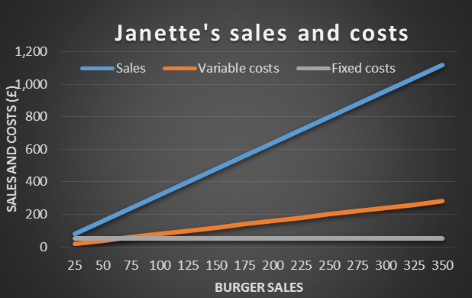
Write an expression for profit. Use the following:
- PT = profit
- P = price at which each burger is sold
- C = cost of each burger to Janette to purchase.
- FC = fixed costs of setting up the pitch.
- B = number of burgers sold

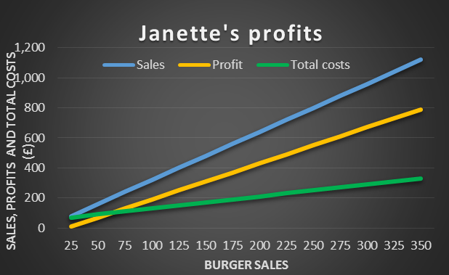

Task 3

The contract to attend the festival offers two pitches: close to the stage or close to the car park. The pitch cost is regarded as a fixed cost. The pitch cost close to the stage is £444 per day and the pitch cost close to the car park is £120 per day.
Janette plans to charge £3.20 per burger which would cost her 80p to buy. Using the profit formula you have calculated solve the following:
- If Janette sold 185 burgers per day, how much profit would she make for the 3 days if she pitched her stall at the car park?
- How much profit would she make for the 3 days if she pitched her stall at the stage?
- How many burgers would Janette need to sell for the 3 days in order to make a profit of at least £2100 if she pitched her stall at the stage?

Homework – customer service

Have a look at the following website and read the short document.
https://www.icaew.com/archive/library/subject-gateways/marketing-and-sales/customer-relations/small-business-update/how-to-deliver-first-class-customer-service
Answer the following question:
Identify 3 key factors that will help Janette to attract customers to her business whilst she is at the festival

Task 4

In order to help Janette to decide whether to pitch her stall at the car park or close to the stage, she has asked the festival organisers to indicate how many customers she will get each hour.
They reply by saying that the number of customers she might get over a 12 hour period is determined by a sequence, depending on where she is located.

CAR PARK
If she located near to the car park, she has been told that customers
will arrive, for each hour, according to the linear sequence: 3n+2, for n=1,2,3,4 …

STAGE
If she is located near to the stage, she has been told that customers
will arrive, for each hour, according to the following quadratic sequence: 0, 3, 8, 15, 24…

From the information provided, answer the following:
- How many burgers does Janette sell during the 5th hour of opening at the car park location?
- Write down a formula for the nth term of the sequence for the stage location.
- How many burgers are sold in the 10th hour at the stage location?

Task 5

Janette has been told by another trader that the sequence of customers arriving at the stage location is a Fibonacci sequence beginning with 1,3.
- How many customers will Jeanette have during the 7th hour?
- Why might customers arrive at Jeanette’s stall in a growth pattern as indicated by a Fibonacci sequence?

