Homework – package holidays
- Use a search engine to find out what is meant by the term ‘package holiday’.
- What items are included in a package holiday?
- What are the advantages and disadvantages of going on a package holiday?
Some answers
- A package holiday is a holiday in which all of the key elements are combined to produce a single price. The key elements are likely to include: flight, hotel, transfers, food, and possibly, activities.
- There are many items. The following is not an exhaustive list
  - Flight
  - Hotel
  - Transfers
  - Food
  - Drinks on all-inclusive holidays
  - Activities (sports, rides, trips and excursions)
  - Flight and seat upgrades
  - Hotel room upgrades
  - Insurance
  - Extra baggage
- Advantages and disadvantages of a package holiday
  - Advantages
    - Can be very cheap
    - Easy to arrange
    - Reliable holidays from trusted operators
    - ATOL protection which applies when the flight and accommodation are booked through a single company which means that you cannot be left stranded abroad or out of pocket if the travel company collapses
    - There is likely to be a tour guide to help deal with any problems
  - Disadvantages
    - Only limited routes. You will have to go where the holidays are available
    - Some people prefer to be independent in their holiday choice and not to be part of a group
    - Independent booking via the internet has opened-up many more opportunities to take holidays where packages are not available

Task 1

Here are some answers to Task 1:
- Before departing
  - Holiday insurance
  - Holiday clothes
  - Transport to airport.
  - Holiday cost.
  - Converting UK currency to Euro: costs of currency conversion.
- Whilst in Spain
  - Meals in Spain
  - Trips and excursions
  - Gifts and souvenirs
  - Holiday treats eg. Beach sports, boats rides, water-park fees, etc.
  - Sundries such as sun cream, drinks, ice creams, snacks, etc.

Here are extended answers to Task 1, before departing, that includes where decisions may be made:
- Before departing
  - Holiday insurance. Decision, either:
    - Take out insurance, or
    - Do no take out insurance
  - Holiday clothes. Decision, either:
    - Pack a light suitcase, or
    - Take a lot of clothes
  - Transport to airport. Decision, either:
    - taxi, bus, train, or
    - car petrol and car parking
  - Holiday cost. Decision, either:
    - Package: hotel, flight, and local transfers (bus/coach from Spanish airport to hotel) included, or
    - Independently booked: hotel, flight, transfers
  - Converting UK currency to Euro: costs of currency conversion. Decision, either:
    - Converted in the UK, or
    - Converted in Spain

Task 2
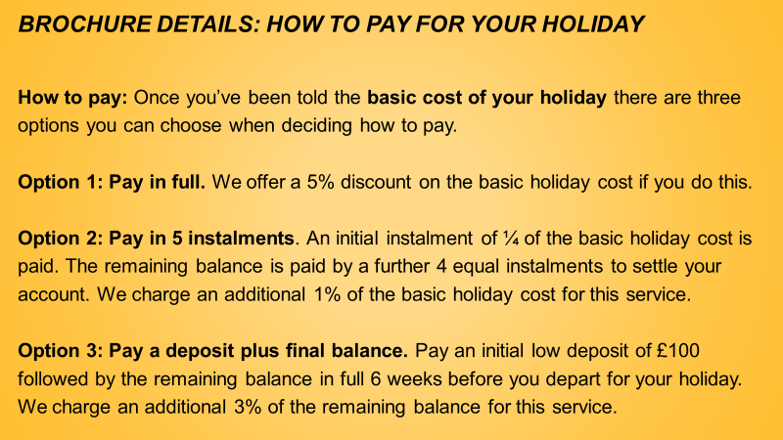
Costs of the holiday under the 3 different options to pay
Basic holiday cost for 4 people: |  |  |  | £2,700
 |  |  |  | £
Option 1 | Basic cost |  |  | 2700.00
 | Discount (5% x £2700) = |  |  | -135.00
 | Cost |  |  | 2565.00
 |  |  |  |  | £
Option 2: | Initial instalment (1/4 x £2700) |  |  |  | 675.00
 | Remaining balance = (2700-675) = |  |  | £2,025
 | Four equal instalments = (2025/4) = |  |  |  | 506.25
 |  |  |  |  | 506.25
 |  |  |  |  | 506.25
 |  |  |  |  | 506.25
 |  |  |  |  | 2700.00
 | Additional charge of 1% of basic holiday cost |  |  |  | 27.00
 | Cost |  |  |  | 2727.00
Option 3
 | Additional charge calculation |  |  |  | £
 | Basic holiday cost |  |  |  | 2700.00
 | Less initial deposit |  |  |  | -100.00
 | Remaining balance |  |  |  | 2600.00
 | Additional charge of 3% of remaining balance |  |  |  | 78.00
 | Total holiday cost
 | Basic cost |  |  |  | 2700.00
 | Additional 3% charge |  |  |  | 78.00
 | Total holiday cost |  |  |  | 2778.00
 | Payment schedule:
 | immediate payment |  |  |  | 100.00
 | balance 6 weeks before holiday |  |  |  | 2678.00
 |  |  |  |  | 2778.00

Homework – exchange rates

The questions were:
- Using the following list, calculate how much the items would cost in £ (sterling) terms by finding out from a search engine what the exchange rate should be:
  - Sun lotion; €4.50 (€)
  - Book: $14.00 (US dollar)
  - Soft drink: 200 Rupee (Indian)
- It is also possible to find an exchange rate for the digital currency, Bitcoin. What would a car cost in £ (sterling) if it was selling for 2 bitcoins?

The answers are:
Using a Google search produces the following exchange rates:
- Various items
  - € : £ = 1.17
  - $ : £ = 1.40
  - Indian Rupee : £ = 90.38
- Bitcoin : £ = 0.00014
And so the costs are:
- Various items:
  - Sun lotion: €4.50 / 1.17 = £3.85
  - Book: $14 / 1.4 = £10
  - Soft drink: Indian Rupee 200 / 90.38 = £2.21
- Bitcoin: £ = 0.00014. Hence 2 bitcoins will cost = 2/0.00014 = £14285

Task 3

Maya at the restaurant
Maya has met two of her school friends at the beach, Reena and Suravi. Maya asked them if they would like to go to dinner with her family. After getting permission, it was agreed that Maya, Reena and Suravi would join Rohan and his mum and dad at the restaurant.
Later that evening, all 6 of them went to the restaurant and had a good time. The dinner bill arrived and showed a total amount due of €120. Maya agreed to help her mum understand the bill as her mum could not remember how to deal with foreign currency. Maya knew that the exchange rate of Euro to Pounds (Sterling) is €1.17: £1 as she had seen it in a shop window earlier in the day.

At the restaurant, problems 1 and 2 are
- Maya’s mum would pay the entire bill on her credit card. What amount in £ would appear on her credit card statement for the restaurant bill?
- Reena and Suravi said that their parents had agreed to pay for their proportion of the bill and that they would settle the bill later in cash. The agreed proportion was 4:2 where Reena and Surayi would pay the lower proportion. What is Reena and Surayi’s combined share of the bill in € ?

Problem 1
The sterling cost of the restaurant bill is €120 / 1.17 = £102.56
Problem 2
The total bill of €120 is going to be divided in the proportions 4:2
For 6 people, this would result in an individual bill of 120/6 = €20.
The bill for Reena and Surayi will be 2 x 20 = €40.

Task 3

At the restaurant, problems 3 and 4 are
- Maya’s mum said that, because she had ordered wine with their meal, it would be fairer if the bill was divided according to ratio 5½ : 2. What is Reena and Surayi’s combined share of the bill in € now ?
Problem 3
The total bill of €120 is now going to be divided by 5½ + 2 = 7½ or 7.5
Dividing the total bill in this way produces €120 / 7.5 = €16
The bill for Reena and Surayi will be 2 x 16 = €32.
The remaining bill will be 5.5 x 16 = €88.
The total amount paid is €32 + €88 = €120.

- Maya’s mum and dad and each drunk a glass of wine. Each glass held 125ml of wine. Wine bottles hold 750ml of wine. Maya’s mum knew at home that a bottle of the same wine would cost £8.25. The cost of the two glasses of wine at the restaurant was €4 and a bottle of the same wine was €11.
    - Is it cheaper to buy wine in the restaurant by the glass or by the bottle?
    - Is a bottle of wine cheaper in the UK or in Spain?
    - What is the percentage difference between the cost of wine in the restaurant compared with the UK?
Problem 4
- Each bottle holds 750ml/125ml = 6 glasses of wine where each glass contains 125ml of wine.
One glass of wine at the restaurant costs €4/2 = €2.
Buying 6 glasses of wine individually would cost 6 x €2 = €12.
This is more expensive than buying the whole bottle at €11.
- The cost of the restaurant wine is €11. Converting this
into £ is €11/1.17 = £9.40. The cost of wine in the UK is £8.25.
The wine is more expensive in Spain compared to the UK.
- The difference in costs between the two wines is £9.40 - £8.25 = £1.15.
The difference or increase in cost is £1.15 / £8.25 = 14%.

Task 4

Maya’s mum tries to check-in their two suitcases at the airport check-in desk. The suitcases are weighed to see if they meet the 20kg limit for each suitcase. The first suitcase weighs 23.3kg. The second suitcase weighs 18kg. They have bought so many souvenirs that they are returning home with more items in the luggage than when they first arrived.
Airlines charge for carrying extra luggage on their flights. For luggage over the 20kg limit, the charge is €5 per kg or each part of a kg. Maya’s mum decides to re-allocate some of the souvenirs from the heavy suitcase to the lighter one.
- What would be the new proportions of weight to minimise the additional charge?
- What charge would Maya’s mum still have to pay after the re-allocation?

What would be the new proportions of weight?
The current proportions of weight are 23.3 : 18.0
Re-allocating 2kg of the souvenirs from the heavier to the
lighter item to use the maximum free allowance of 20kg
would give the following new proportions: 23.3 – 2.0 = 18.0 + 2.0, or 21.3 : 20.

What penalty would Maya’s mum still have to pay?
The first item of luggage is still overweight by 21.3 – 20 = 1.3. This would incur a penalty of €10.

https://www.caa.co.uk/atol-protection/consumers/about-atol/

