Homework- package holidays

- Use a search engine to find out what is meant by the term ‘package holiday’.
- What items are included in a package holiday?
- What are the advantages and disadvantages of going on a package holiday?

Task 1
Working in pairs, identify what Maya would need to think are going to be the likely items that her family will spend money on if they book a holiday to Spain. Think about what they might spend before they depart for the holiday and also whilst they are on holiday.
Before going on holiday

1

2

3

4

5

Whilst on holiday in Spain

1

2

3

4

5

Task 2

Maya wants to work out which would be the best way to pay for the holiday. She has calculated that the basic cost of the holiday for 4 people is £2,700. Let’s help her finish the work.
Working in pairs
  - from the details in the brochure, identify what is the cheapest option to pay for the holiday by working out the cost of the holiday that would be paid under each option.
  - explain why the cheapest option might not be the best option for Maya’s family.

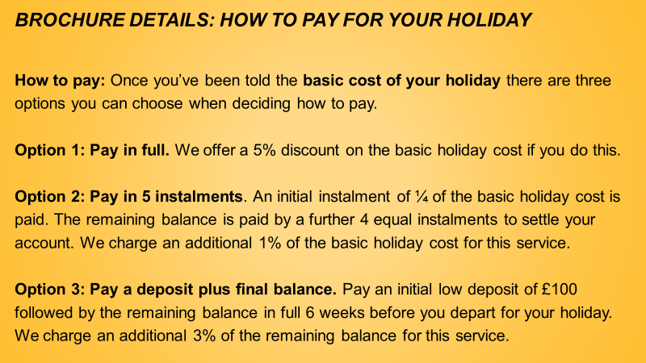

Homework – exchange rates

- Using the following list, calculate how much the items would cost in £ (sterling) terms by finding out from a search engine what the exchange rate should be:
  - Sun lotion; €4.50 (€)
  - Book: $14.00 (US dollar)
  - Soft drink: 200 Rupee (Indian)
- It is also possible to find an exchange rate for the digital currency, Bitcoin. What would a car cost in £ (sterling) if it was selling for 2 bitcoins?

Task 3

Maya wants to help her mum with calculations involving the restaurant bill.
Working in pairs, using the information below:
- Maya’s mum would pay the entire bill on her credit card. What amount in £ would appear on her credit card statement for the restaurant bill?
- Reena and Suravi said that their parents had agreed to pay for their proportion of the bill and that they would settle the bill later in cash. The agreed proportion was 4:2 where Reena and Surayi would pay the lower proportion. What is Reena and Surayi’s combined share of the bill in € ?

Maya at the restaurant
Maya has met two of her school friends at the beach, Reena and Suravi. Maya asked them if they would like to go to dinner with her family. After getting permission, it was agreed that Maya, Reena and Suravi would join Rohan and his mum and dad at the restaurant.
Later that evening, all 6 of them went to the restaurant and had a good time. The dinner bill arrived and showed a total amount due of €120. Maya agreed to help her mum understand the bill as her mum could not remember how to deal with foreign currency. Maya knew that the exchange rate of Euro to Pounds (Sterling) is €1.17: £1 as she had seen it in a shop window earlier in the day.

Task 3

Maya wants to help her mum with further calculations involving the restaurant bill.
- Maya’s mum said that, because she had ordered wine with their meal, it would be fairer if the bill was divided according to ratio 5½ : 2. What is Reena and Surayi’s combined share of the bill in € now ?
- Maya’s mum and dad and each drunk a glass of wine. Each glass held 125ml of wine. Wine bottles hold 750ml of wine. Maya’s mum knew at home that a bottle of the same wine would cost £8.25. The cost of the two glasses of wine at the restaurant was €4 and a bottle of the same wine was €11.
    - Is it cheaper to buy wine in the restaurant by the glass or by the bottle?
    - Is a bottle of wine cheaper in the UK or in Spain?
    - What is the percentage difference between the cost of wine in the restaurant compared with the UK?

Task 4

Help Maya’s to sort out her mum’s luggage problems!

Maya’s mum tries to check-in their two suitcases at the airport check-in desk. The suitcases are weighed to see if they meet the 20kg limit for each suitcase. The first suitcase weighs 23.3kg. The second suitcase weighs 18kg. They have bought so many souvenirs that they are returning home with more items in the luggage than when they first arrived.
Airlines charge for carrying extra luggage on their flights. For luggage over the 20kg limit, the charge is €5 per kg or each part of a kg. Maya’s mum decides to re-allocate some of the souvenirs from the heavy suitcase to the lighter one.
- What would be the new proportions of weight to minimise the additional charge?
- What charge would Maya’s mum still have to pay after the re-allocation?

