Homework

Choose a city in the UK that has a university and try to identify five key factors that influence rentals in the city.
Tip: it might be worthwhile finding out first what general factors determine rent and then see, for the city of your choice, what specific factors determine rent.

Task 1

Working in pairs, list all the reasons that you can think of that would make you choose to go to university. Think about the reasons which are different to financial ones such as making new friends.
Reason to go to university

1

2

3

4

5

6

7

8

9

10

Task 2

Working in pairs, identify all of the likely costs that Rohan will face if he moves out of his home to attend university in a different town. Three columns setting-out the broad areas of spending have already been written for you. Write under each column heading what you think the costs might be.

Accommodation costs | Day to day costs | University/studying costs

Task 3

Is the newspaper article correct?
Split into two groups (group A and group B) and pair-up with a friend.
- Group A pairs
  - Produce a scatter diagram with house costs on the horizontal axis and rental costs on the vertical axis.
  - Draw a line of best fit to the data
- Group B pairs
  - Produce a scatter diagram with student population on the horizontal axis and rental costs on the vertical axis.
  - Draw a line of best fit to the data
University | House cost | Weekly rent | Student Popn.
 | £ | £ | %
University College London | 420000 | 130.33 | 11.46
University of Bristol | 205000 | 114.28 | 12.05
University of Cardiff | 165250 | 81.47 | 16.84
University of Exeter | 335000 | 117.25 | 18.63
University of Leicester | 120500 | 90.55 | 9.00
University of Newcastle | 145000 | 95.00 | 10.50
University of Norwich | 242500 | 91.80 | 12.09
University of Oxford | 340000 | 135.83 | 26.69
University of Portsmouth | 325625 | 101.61 | 13.83
University of Reading | 440000 | 115.79 | 14.70
Mean all data | 273888 | 107.39 | 14.58

Task 4

Working in pairs and your groups and using the scatter diagrams and lines of best fit that you have already drawn, answer the following problem: Rohan is considering two options for university towns that his parents have mentioned:
- Town X where average house prices are £300,000. Group A: Using the line of best fit that you have drawn, find out how much rental Rohan might pay in Town X.
- Town Y where student populations are very high at 28%. Group B: Using the line of best fit that you have drawn, find out how much rental Rohan might pay in Town Y.
Use the scatter diagrams you have drawn, including Oxford.
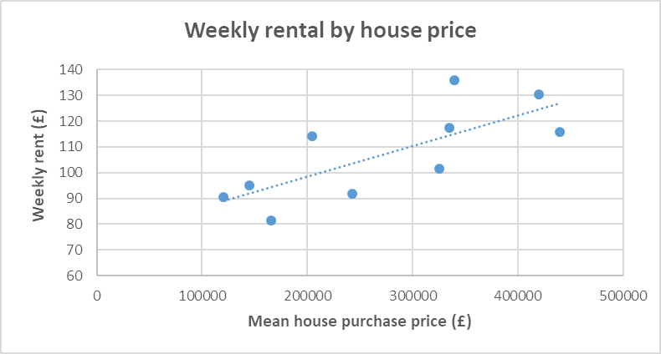
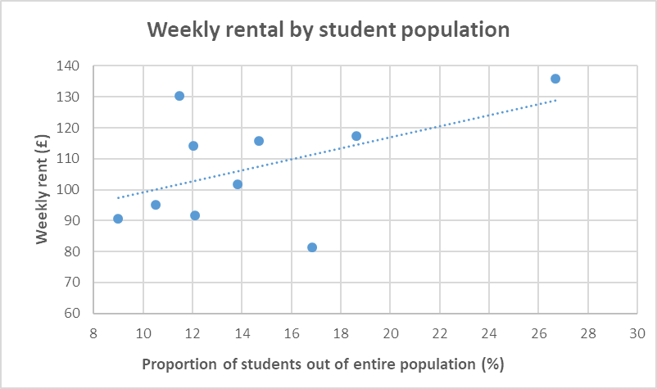

Homework – borrowing to finance university education

Tuition fees to attend a university in England or Wales currently cost up to £9250 in England and £9000 in Wales. There are arrangements in place to pay back the loan a student takes out.
Have a look at the website below and answer the following questions.
- Do I have to pay back all of the loan?
- When do you have to start paying back the loan?
- How much would my monthly repayments be if I earned £30,000 after graduation?
https://www.gov.uk/repaying-your-student-loan

Task 5

Rohan has also heard that your choice of subject at university can affect your earnings. Have a look at the data on the handout which shows starting salaries for a number of subjects.
Working in pairs: calculate the average, median, mode and range of the data and answer the following questions that Rohan has raised:
- Why are the loan repayments higher for subjects like Actuarial work and Information Technology?
- Would it be better if Rohan chose a low loan repayment course such as Retail Management?
- The average and the median of the salaries should be close together in your calculations, but the mode is much lower. Why is the mode different?
- What message is your value of the range of monthly repayments giving to Rohan?
- What course would you advise Rohan doing? Why?
 | Starting | Monthly
 | salary | repayment
 | (£) | (£)
Accountancy | 27,000 | 15.00
Actuarial work | 29,250 | 31.88
Civil Engineering | 25,250 | 1.88
Management | 26,000 | 7.50
Information technology | 28,000 | 22.50
Marketing | 27,250 | 16.88
Mechanical engineering | 25,250 | 1.88
Retail management | 26,000 | 7.50
Science | 27,250 | 16.88
Veterinary science | 25,250 | 1.88

Task 6

Rohan has been asked by his maths teacher to present some of his work to the whole class so that his friends could also understand what it costs to go to university. Specifically, in your pairs:
- From the starting salaries data, complete the frequency table using the following class intervals
- Draw a frequency polygon of your results
- What do the frequency intervals tell us about starting salaries between degree subjects?
 | Starting | Monthly
 | salary | repayment
 | (£) | (£)
Accountancy | 27,000 | 15.00
Actuarial work | 29,250 | 31.88
Civil Engineering | 25,250 | 1.88
Management | 26,000 | 7.50
Information technology | 28,000 | 22.50
Marketing | 27,250 | 16.88
Mechanical engineering | 25,250 | 1.88
Retail management | 26,000 | 7.50
Science | 27,250 | 16.88
Veterinary science | 25,250 | 1.88

Salary range | Frequency
£25,000≤x<£26,000
£26,000≤x<£27,000
£27,000≤x<£28,000
£28,000≤x<£29,000
£29,000≤x<£30,000

