Homework – factors influencing rents

Here are some suggested answers that apply to Leeds
- High number of visitors increasing short term lets and reducing availability of long term lets
- Large number of jobs in sectors that recruit young people (high tech)
- Three universities creating huge student demand
- Continued development of business and housing creating tenant interest
- Good commuting networks that, in turn, increase business and employment within the city
Other factors might include
- Good quality of life, particularly for students
- Excellent external impression that Leeds is a good place to live
- The standing of the University of Leeds is high as one of the leading Russell group universities
- The demographics of the area are important if there is a high proportion of young people who cannot afford mortgages but can afford rentals.

Task 1

Some reasons that are not financial why pupils may wish to attend university:
- You can achieve something worthwhile.
- You can pursue an interest.
- You can access jobs that are only open to university graduates eg dentists.
- You can choose a university in a location that suits you.
- You can enjoy sports, hobbies, and a whole range of student-created activities.
- You are more likely to find the job that you want: the wider availability of jobs at graduate level widens choice.
- You can widen your circle of friends and have an enjoyable time whilst studying something you are interesting in.
- You can develop key skills such as self-motivation, communication, teamwork, problem-solving, organisation, self-management, the ability to learn, and advanced technology.
- You are more likely to find a job with better job satisfaction.
- You can take the opportunity of living semi-independently as an important first-step in moving out of home.

Task 2

Identify all of the likely costs that Rohan will face if he moves out of his home to attend university in a different town. Three columns setting-out the broad areas of spending have already been written for you. Write under each column heading what you think the costs might be.

Accommodation costs | Day to day costs | University/studying costs
Electricity | Groceries | University Fees
Gas | Eating Out/Socialising | Computer/Laptop
Water | Hobbies/Sports | Books, Pens and Writing Pads
Council Tax | Transport and Travel
Home Entertainment | Mobile Phone
Rent and Rent/Security Deposits | Clothes/Shoes/Accessories

Task 3

Is the newspaper article correct?
Split into two groups (group A and group B) and pair-up with a friend.
- Group A pairs
  - Produce a scatter diagram with house costs on the horizontal axis and rental costs on the vertical axis.
  - Draw a line of best fit to the data
- Group B pairs
  - Produce a scatter diagram with student population on the horizontal axis and rental costs on the vertical axis.
  - Draw a line of best fit to the data
University | House cost | Weekly rent | Student Popn.
 | £ | £ | %
University College London | 420000 | 130.33 | 11.46
University of Bristol | 205000 | 114.28 | 12.05
University of Cardiff | 165250 | 81.47 | 16.84
University of Exeter | 335000 | 117.25 | 18.63
University of Leicester | 120500 | 90.55 | 9.00
University of Newcastle | 145000 | 95.00 | 10.50
University of Norwich | 242500 | 91.80 | 12.09
University of Oxford | 340000 | 135.83 | 26.69
University of Portsmouth | 325625 | 101.61 | 13.83
University of Reading | 440000 | 115.79 | 14.70
Mean all data | 273888 | 107.39 | 14.58

Correlation = 0.75
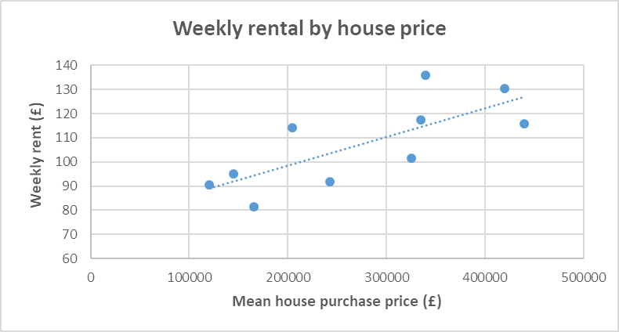

Correlation = 0.51

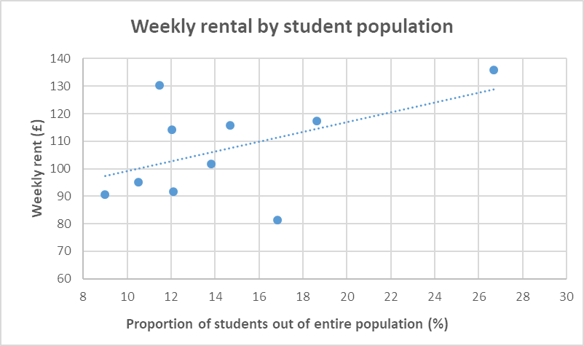

Correlation = 0.09

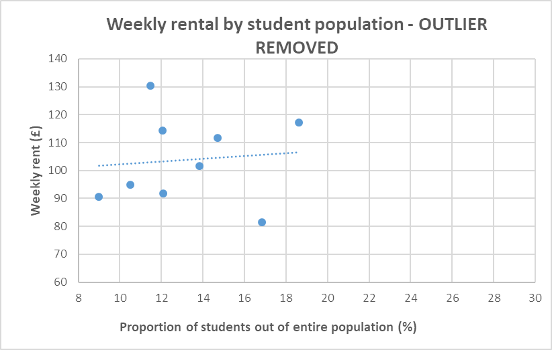

Task 4

Working in pairs and your groups and using the scatter diagrams and lines of best fit that you have already drawn, answer the following problem: Rohan is considering two options for university towns that his parents have mentioned:
- Town X where average house prices are £300,000. Group A: Using the line of best fit that you have drawn, find out how much rental Rohan might pay in Town X.
- Town Y where student populations are very high at 28%. Group B: Using the line of best fit that you have drawn, find out how much rental Rohan might pay in Town Y.
Use the scatter diagrams you have drawn, including Oxford.

The interpolated rent appears to be at about £110 per week for a house purchase price of £300,000.

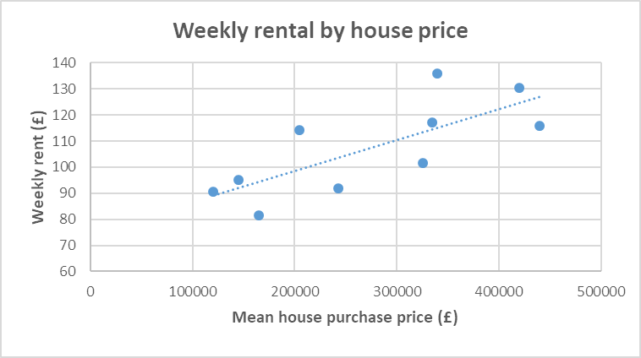

The extrapolated rent appears to be at about £123 per week for a proportion of 28%

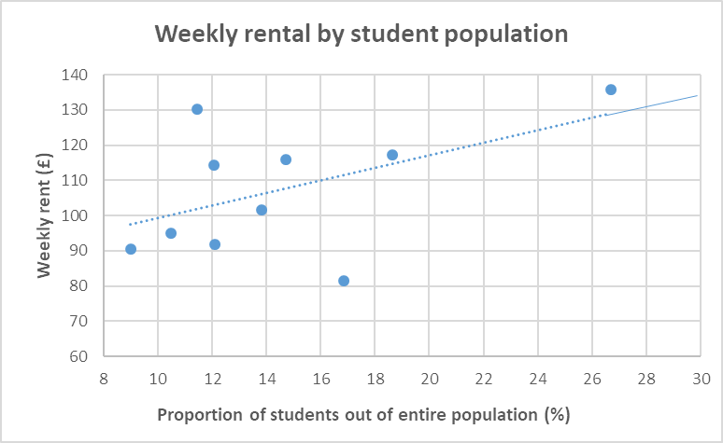

Homework – borrowing to finance university education

Tuition fees to attend a university in England or Wales currently cost up to £9250 in England and £9000 in Wales. There are arrangements in place to pay back the loan a student takes out.
Have a look at the website below and answer the following questions.
- Do I have to pay back all of the loan?
- When do you have to start paying back the loan?
- How much would my monthly repayments be if I earned £30,000 after graduation?
https://www.gov.uk/repaying-your-student-loan

- Student loans for tuition fees are known as income-contingent loans: the amount paid-back is referenced to the income level of the former student. It is possible that the amount borrowed may never be paid back because the former student might not have earned enough before the 30-year deadline is reached at which point the loan is written-off. However, the website makes clear that the loan has to be repaid, which appears contradictory. Loans are written-off if they are not paid back by 30 years after the 1st April following graduation (which is the time the first repayments are due – see below).

- All loans that are made are under Plan 2 which is for students beginning university after 1 September 2012. In this case, loan repayments begin when annual income levels reach £25,000. If income levels have reached £25,000 then the earliest start for loan repayments to begin is either the:
- April after the course finishes for full time students, or
- April four years after the course started, for part time students.

- The website gives a specific example for Plan 2 repayments if £30,000 is earned after graduation and the amount is £37 per month. The rule for Plan 2 is that 9% of income over £25,000 is repaid. This would amount to, for an income of £30,000:

[ (30,000 – 25,000) x 0.09 ] /12 = £37.53 or £37 as described on the website.
.

Task 5

Rohan has also heard that your choice of subject at university can affect your earnings. Have a look at the data on the handout which shows starting salaries for a number of subjects.
Working in pairs, calculate the average, median, mode and range of the data and answer the following questions that Rohan has raised:
- Why are the loan repayments higher for subjects like Actuarial work and Information Technology?
- Would it be better if Rohan chose a low loan repayment course such as Retail Management?
- The average and the median of the salaries should be close together in your calculations, but the mode is much lower. Why is the mode different?
- What message is your value of the range of monthly repayments giving to Rohan?
- What course would you advise Rohan doing? Why?

 | Starting | Monthly
 | salary | repayment
 | (£) | (£)
Accountancy | 27,000 | 15.00
Actuarial work | 29,250 | 31.88
Civil Engineering | 25,250 | 1.88
Management | 26,000 | 7.50
Information technology | 28,000 | 22.50
Marketing | 27,250 | 16.88
Mechanical engineering | 25,250 | 1.88
Retail management | 26,000 | 7.50
Science | 27,250 | 16.88
Veterinary science | 25,250 | 1.88

 | Starting | Monthly
 | salary | repayment
 | (£) | (£)
Mean | 26,650 | 12.38
Median | 26,500 | 11.25
Mode | 25,250 | 1.88
Range | 4,000 | 30

Possible responses to questions:

- The loan repayments are higher in Actuarial work and Information Technology because expected salaries are higher. It is not because these courses cost more. Remember that loan repayments are based on earnings not on the amount loaned.
- Whichever subject Rohan chooses should not be based on the loan repayment level. The fact that Retail Management looks ‘low cost’ is because salary expectations are low.
- The mode is different because it only considers the highest frequency amount appearing in the data. It does not consider what value the data is. In this instance, the mode just happens to be at a relatively low value of starting salary and loan repayments. The average and the median take account of the value of the data (effectively, how ‘big’ or ‘small’ the number is) and hence will be calculated at approximately the ‘centre’ of the values.
- The range of the monthly repayments is £30. It is large in relation to the average and the median, and is certainly large in relation to the mode. It tells Rohan that the loan repayments vary a great deal. Since the loan repayments are based on salaries this also means that salaries vary a great deal.
- Rohan should bring into consideration many other important factors when choosing a degree subject. Expected salary is one but others would be choosing a subject which interest him or for which he has the right aptitude and interest.

Task 6

Rohan has been asked by his maths teacher to present some of his work to the whole class so that his friends could also understand what it costs to go to university. Specifically, in your pairs:
- From the starting salaries data, complete the frequency table using the following class intervals (next slide)
- Draw a frequency diagram of your results
- What do the frequency intervals tell us about starting salaries between degree subjects?

 | Starting | Monthly
 | salary | repayment
 | (£) | (£)
Accountancy | 27,000 | 15.00
Actuarial work | 29,250 | 31.88
Civil Engineering | 25,250 | 1.88
Management | 26,000 | 7.50
Information technology | 28,000 | 22.50
Marketing | 27,250 | 16.88
Mechanical engineering | 25,250 | 1.88
Retail management | 26,000 | 7.50
Science | 27,250 | 16.88
Veterinary science | 25,250 | 1.88

Salary range |  | Frequency | Midpoint
£25,000≤x<£26,000 |  | 3 | 25500
£26,000≤x<£27,000 |  | 2 | 26500
£27,000≤x<£28,000 |  | 3 | 27500
£28,000≤x<£29,000 |  | 1 | 28500
£29,000≤x<£30,000 |  | 1 | 29500
 |  | 10

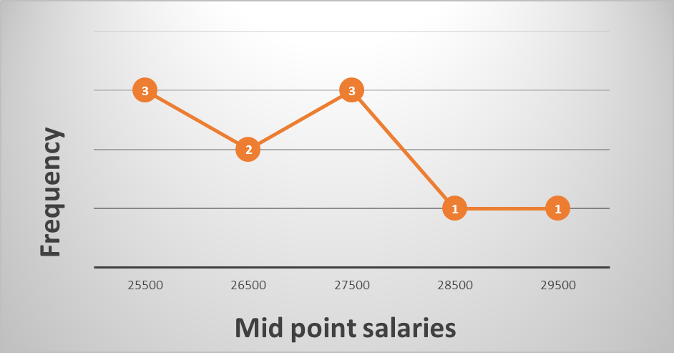

https://www.moneyadviceservice.org.uk/en/articles/repaying-student-loans

